10/10/2025

Measuring the Boiling Point of Water at Different Altitudes

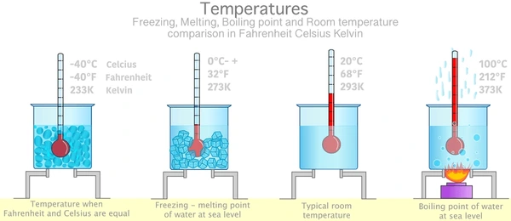

(20117676) Paula Staszewska

***Table of Contents***

***Title 2***

***1. Aim 2***

***2. Theory 2***

***2.1 Introduction to Clausius–Clapeyron equation 2***

***2.2 Relationship between boiling point and pressure 2***

***3. Apparatus 2***

***4. Method 2***

***6. Calculations 3***

***7. Discussion/Conclusion 3***

# Title

Measuring the Boiling Point of Water at Different Altitudes

# 1. Aim

To determine how altitude affects the boiling point of water and to compare the measured values with theoretical expectations.

# 2. Theory

# 2.1 Introduction to Clausius–Clapeyron equation

The **Clausius–Clapeyron equation** describes how the pressure and temperature of a substance are related during a phase change — for example, when a liquid boils or a solid melt.

It shows that as temperature increases, the vapour pressure of a liquid also increases. This is because heating gives the molecules more energy to escape from the liquid surface.

In this experiment, the equation helps **explain why the boiling point of water decreases at higher altitudes:**

* Air pressure is lower at high altitudes.
* According to the equation, lower pressure means boiling happens at a lower temperature.

# 2.2 Relationship between boiling point and pressure

The relationship between boiling point and pressure can be estimated using the Clausius–Clapeyron equation:

ln ($\frac{p_{1}}{P_{2}}$) = $\frac{{∆H}_{vap} }{R}$ ($\frac{1}{T_{1}}- \frac{1}{T_{2}}$)

where ${∆H }_{vap}$ is the enthalpy of vaporization, R is the gas constant, and T represents absolute temperature.

# 

# 3. Apparatus

* Thermometer
* 250 mL Beaker
* Hot plate
* Distilled water
* Barometer
* Stopwatch

4. Method

1. Fill a 250 mL beaker halfway with distilled water.
2. Measure and record the atmospheric pressure using a barometer.
3. Place the beaker on a hot plate and heat gradually
4. Repeat the experiment at three simulated altitudes by adjusting the air pressure in a sealed chamber (or use provided data).
5. Record all data and calculate the boiling point deviation from the theoretical 100 °C.

|  |  |  |  |
| --- | --- | --- | --- |
| Altitude (m) | Pressure (kPa) | Boiling Point (°C) | Deviation (°C) |
| **0** | 101.3 | 100.0 | 0.0 |
| **500** | 95.5 | 98.6 | -1.4 |
| **1000** | 89.9 | 97.2 | -2.8 |
| **1500** | 94.2 | 96.0 | 4.0 |

# Calculations

Percentage deviation from standard boiling point (100 °C):

Percentage deviation = $\frac{100- Tmeasured }{100}$ × 100

At 1500 m, deviation $\frac{4}{100}$ × 100 = 4%

# Discussion/Conclusion

The data clearly shows a decrease in boiling point with increasing altitude, consistent with the theoretical relationship between pressure and temperature.

Minor experimental deviations could result from thermometer calibration or inconsistent pressure readings.

This experiment demonstrates the importance of considering environmental conditions in temperature-sensitive scientific measurements.